Output of this code

1.Output of login page:-

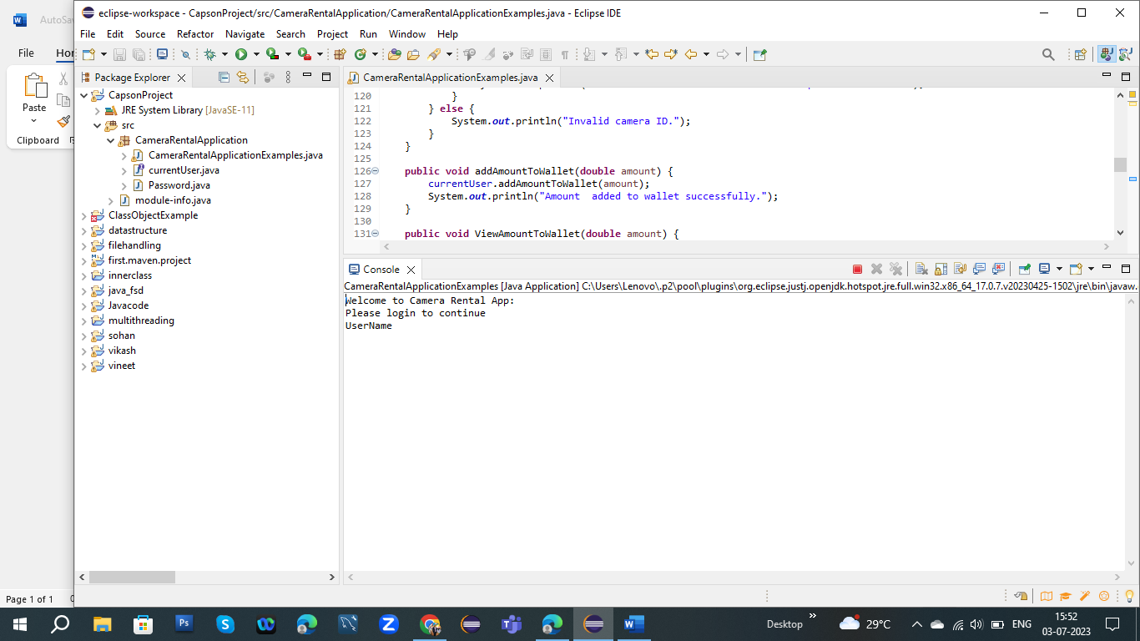

2.If user put the detail of username or password in login page:-

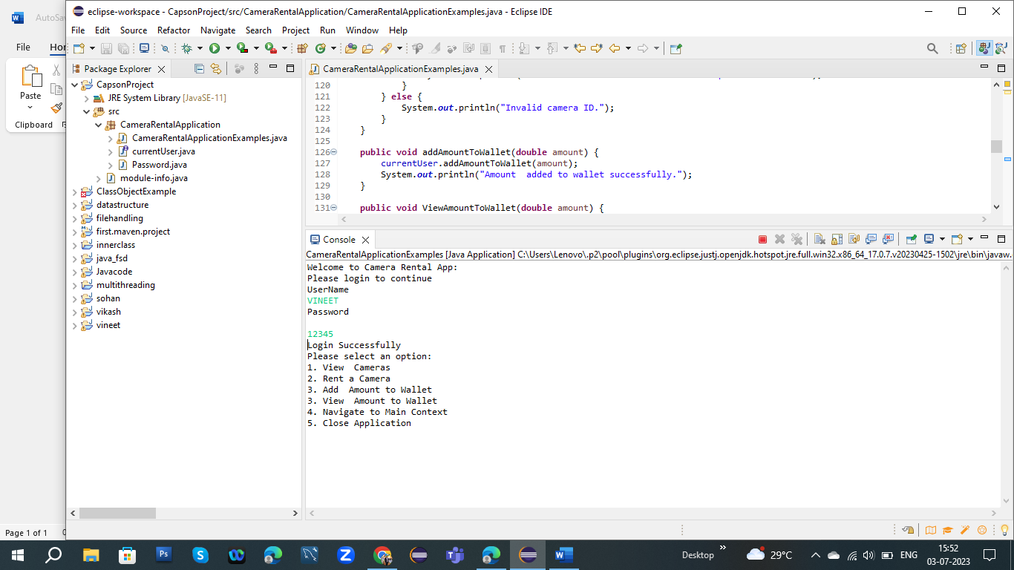

3. Output of Displayed login pages:-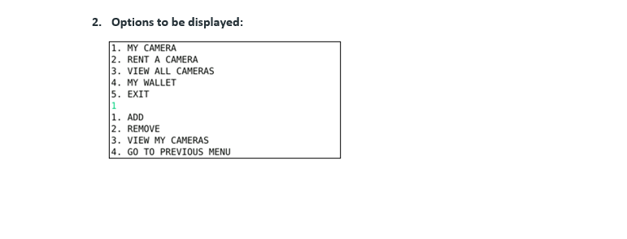

4.Output of view camera list:-

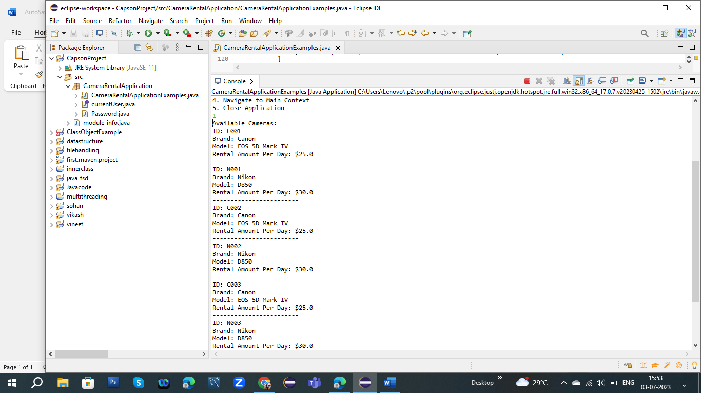

5.Output of add camera in application:-

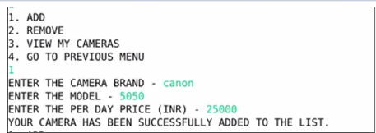

6.Output of camera to remove the application:-

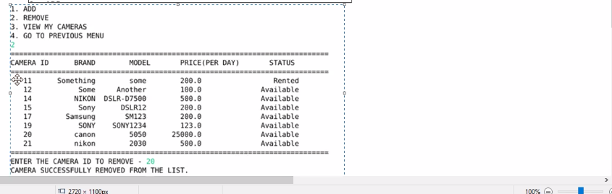

7.Output of my wallet:-

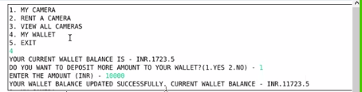

8.Close the all the process of output:-

